**Translate Fiori Launchpad Tiles from English to Japanese on the ABAP stack**

1. Before we can start with the translation, first we need to know which tile we are going translate.

Then login into the Configuration/Fiori Launchpad Designer and search for the catalog of our tile

<http://HostName:PortNumber/sap/bc/ui5_ui5/sap/arsrvc_upb_admn/main.html>

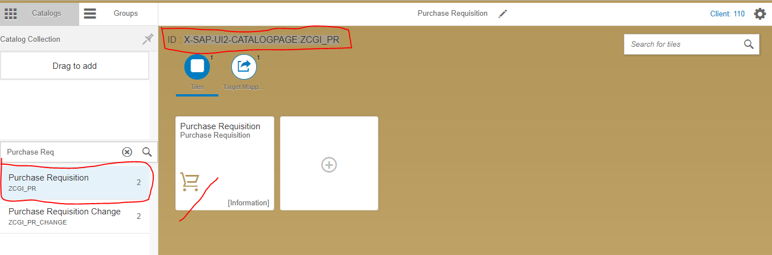

In this document I will translate the text of the “Purchase Requisition” tile to Japanese.

Important for the translation is the id of the catalog with is located in the left upper corner (highlighted by Red Color).

In our example this is “ID: **X-SAP-UI2-CATALOGPAGE:ZCGI_PR** ”

**Translation**

* Most of the translations within the ABAP stack can be done in transaction **SE63**.

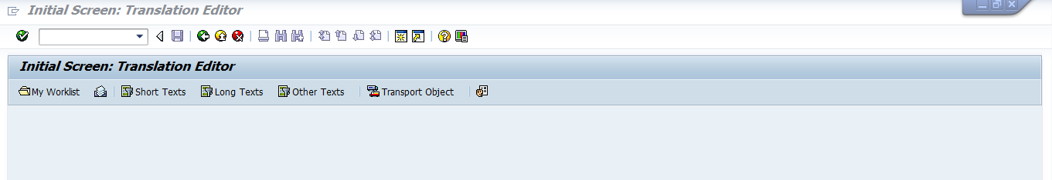

* In the top menu we choose **Translation -> ABAP Objects -> Short Text** or shortly press **CTRL-F2**.

This will open a screen where we can select the type of object we want to translate.

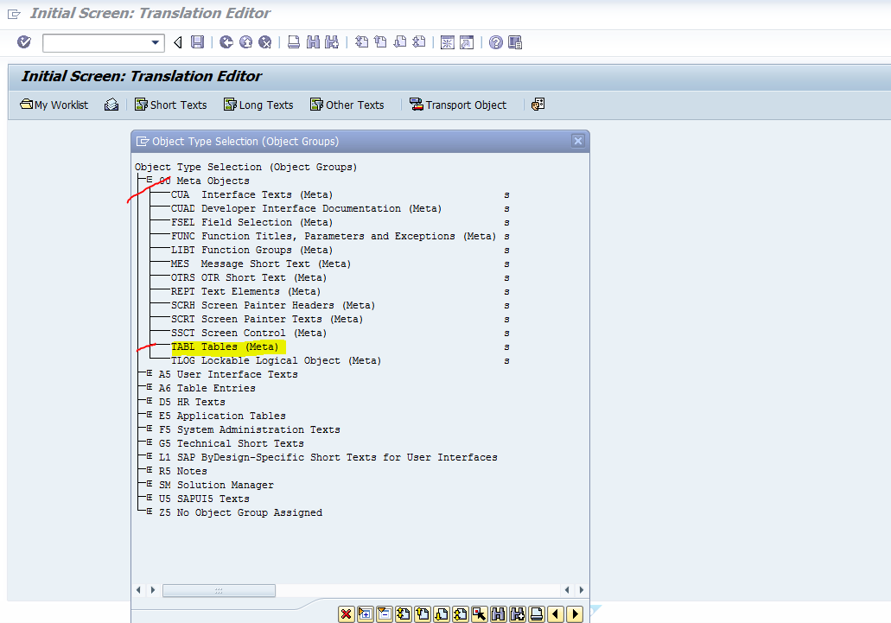

In our case,

* We need the object type **TABL Tables (Meta)** which can be found below **00 Meta Object** in Net Weaver stack 7.40 or Higher.

Before Net Weaver 7.40, you will find this object below **A6 Table Entries**.

* Just double click on “**TABL Table (Meta)**”. Its open below screen shot screen

Here

Object Name: “**WDY_CONF_USERT2** “and **Source Language** and **Target Language** as per the requirement.

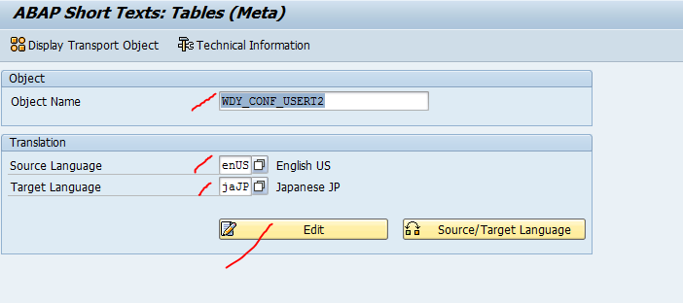

* Click on **“Edit”**

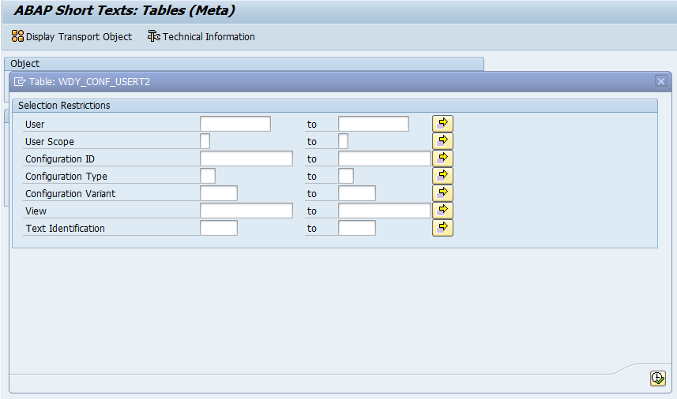

* Click on “Configuration ID” value help. Its open below screen shot

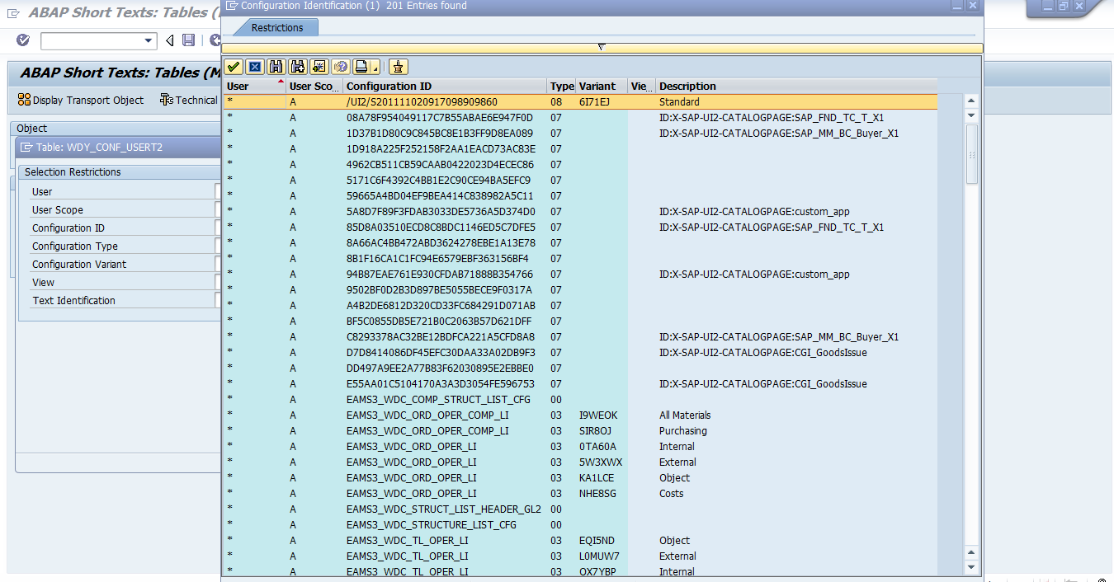

* Here find the configuration id using Description ID( as per Point 1) and select correct configuration id

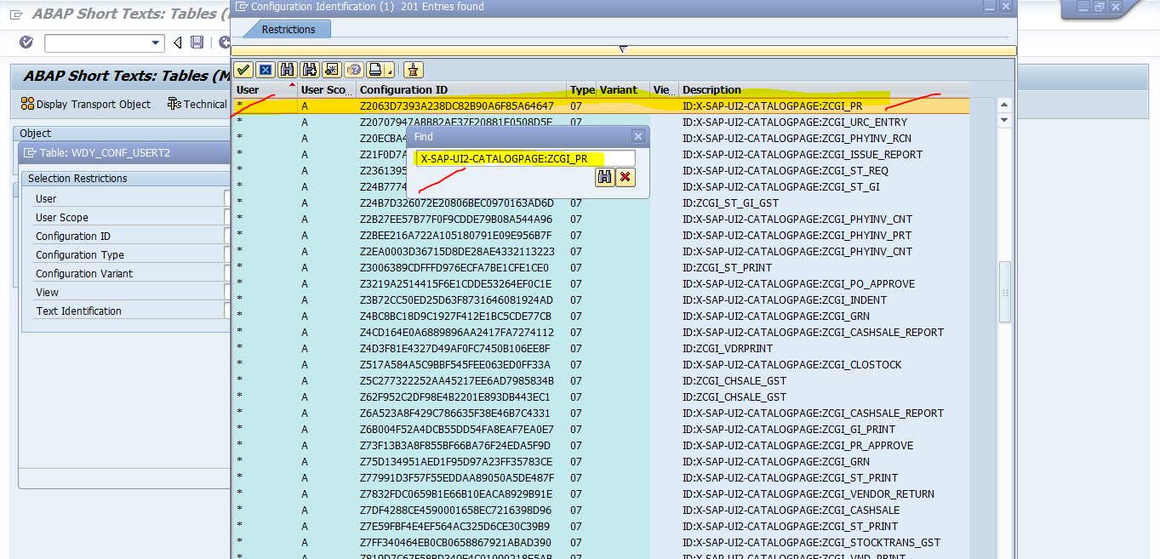

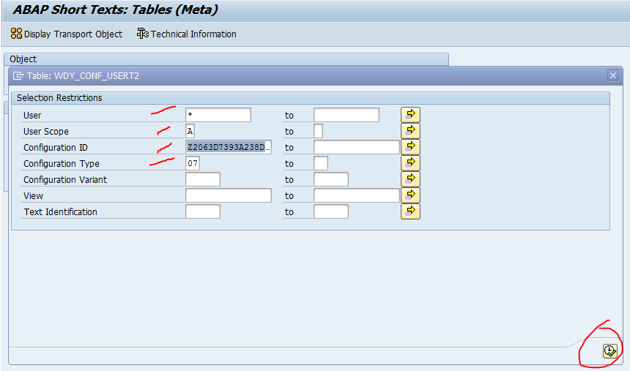

* Click on **“Execute”** Button.

Here give the corresponding Japanese desertion (highlighted by red color) and click on **“Save”**

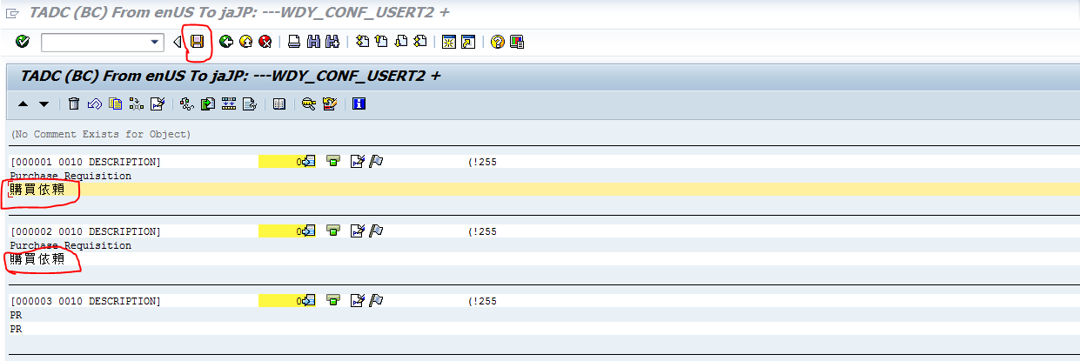

* Finally Clear Cache under SE38

Program: /UI2/INVALIDATE_CLIENT_CACHES

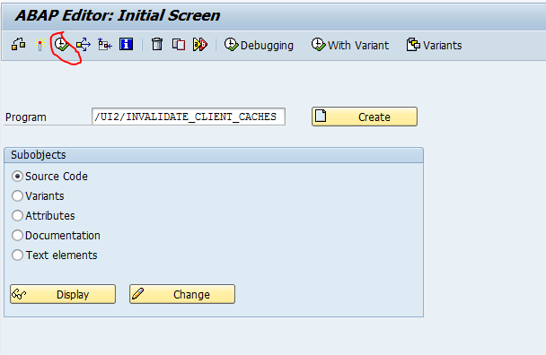

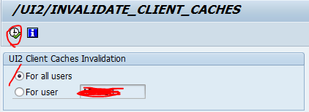

Program: /UI2/INVALIDATE_GLOBAL_CACHES

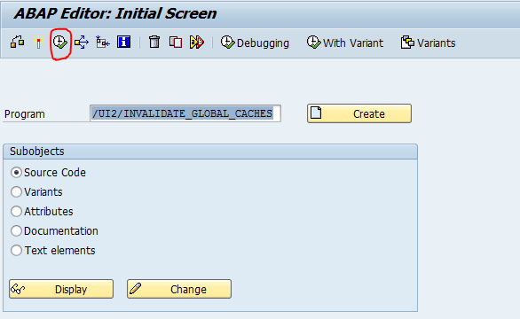

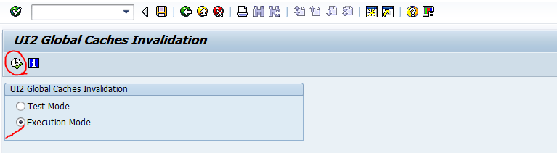

* Finally while login into FLP using Japanese language. You will get Japanese language description on Tile.

